Want to Write Songs this Summer?
Check out these awesome videos to learn song great songwriting information, tips, and tricks!

What are the parts of a song? Verse, Chorus (Refrain), and Bridge
https://safeYouTube.net/w/Fz7H

What order are the verse, chorus, and bridge in a song?
https://safeYouTube.net/w/vF7H

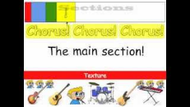
https://safeYouTube.net/w/b87H

What should your song be about? Here are some great ideas for lyrics!
Lyrics- words to the song
https://safeYouTube.net/w/xc8H

Here are some fun song/ lyric writing exercises to try.
https://safeYouTube.net/w/gr8H

Rhyming Tips for your song lyrics.
https://safeYouTube.net/w/j08H

How do you write a melody? Using pitch and rhythm of course!
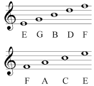
Pitch- we think of pitch as how high or low the note sounds. We write pitch on the STAFF in music class. Remember EGBDF and FACE?

Rhythm- the short, long, and silent sounds in music.
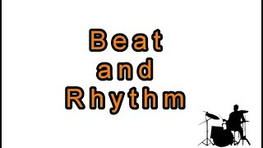
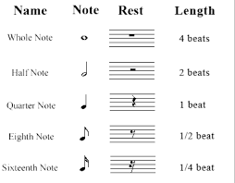

https://safeYouTube.net/w/ZV8H

Writing a Melody
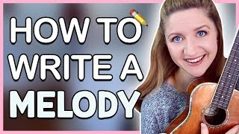 https://safeYouTube.net/w/Pe9H

I hope you have fun songs! Email me your song videos at cranee@fultonschools.org

